**Project Synopsis**

**Night Vision Image: Fusion of low-light visible and thermal IR imagery**

**Submitted by**

Nitin P Khatawate – 1DS13CS067

Shivprasad Achari - 1DS13CS091

Soumil Biswas - 1DS13CS099

Tanish V Sugnani – 1DS13CS110

**Under the guidance of**

Dr. Shubha Bhat and Prof. Shashidhara Bola

**Designation**

Assistant professor CSE, DSCE



**Department of Computer Science & Engineering**

**DAYANANDASAGARCOLLEGE OF ENGINEERING**

**ShavigeMalleswara Hills, Kumarswamy Layout, Bangalore-560078**

**Ph: 26662226 / 26660789 / Fax: 080-26660789,Website:www.dayanandasagar.edu**

**Contents**

1. Introduction……………………………………………………………………… 1
2. Objective ……………………….……………………………………………….. 2
3. Problem Statement ………………………………………………………………. 2
4. Literature Review……………………………………………………………….. 3
5. Existing State-Of -The-Art…………………………………………………….... 4
6. Proposed System………………………………………………………………… 4
7. System Requirements…………………………………………………………… 5
8. Expected Results……………………………………………………………….... 7
9. Conclusion And Future Work…………………………………………………... 7
10. References………………………………………………………………………. 8
11. **Introduction**

* In computer vision, Multisensor **Image fusion** is the process of combining relevant information from two or more images into a single image. The resulting image will be more informative than any of the input images.
* Real-time implementation of the dual sensor fusion system combines imagery from either a **low-light CCD camera** or a **short-wave infrared camera**, with thermal long-wave infrared imagery.
* Multi-sensor based image fusion system is a fundamental to several modern day image processing applications, such as security systems, defence applications, and intelligent machines.
* In this paper, we concentrate on the fusion of multi-sensor data such as thermal infrared (IR) and visible images, which can lead to better performance for human visual perception, object detection, as well as target recognition .
* The goal of image fusion is to identify the most important information in the source images and to transfer, without distortion or loss, this information into a fused image.

1. **Objective**

* The main objective is to develop a new prototype system enhance the information of output image citied when two images IR image and CCD image are fused together in many applications, especially in the field of security domain. Our objective is to increase the image quality by detecting and reducing the several particular kinds of distortion.

1. **Problem Statement**

* In night-time environment, only limited visual information can be captured by CCD cameras under poor lightning conditions, thus making it difficult to do surveillance only by visual sensor.

1. **Literature Review**
2. **Title:** "Infrared and visible image fusion with the use of multi-scale edge-preserving decomposition and guided image filter”

**Author:** Wei Gan, Xiaohong Wu, Wei Wu, Xiaomin Yang, Chao Ren, Xiaohai He, Kai Liu

**Publication:** ELSEVIERInfrared Physics & Technology, Volume 72, September 2015, Pages 37–51

* In this paper a novel IR and VIS image fusion framework is proposed by combining multi-scale decomposition and guided filter. The proposed scheme could not only preserve the details of source IR and VI images but could also suppress the artifacts effectively by combining the advantages of multi-scale decomposition and guided filter.
* First, both IR and VIS images are decomposed with a multi-scale edge-preserving filter. Saliency maps of IR and VIS images are then calculated on the basis of phase congruency. Subsequently, the guided filtering is adopted to generate weighting maps. Finally, the resultant image is reconstructed with the weighting maps. Phase congruency (PC) rather than Laplace operator is adopted in this study to obtain better saliency maps, which improves the performance of the proposed method. Representative experiments show that the proposed method outperforms existing methods in image quality.

1. **Title:** "An adaptive fusion approach for infrared and visible images based on NSCT and compressed sensing"

**Author:** Qiong Zhang , Xavier Maldague

**Publication:** ELSEVIER Infrared Physics & Technology, Volume 74, January 2016, Pages 11–20

* A novel non-subsampled contourlet transform (NSCT) based image fusion approach is proposed for the fusion computation of infrared and visible images.
* In the proposed fusion process, the pre-enhanced infrared image and the visible image are decomposed into low-frequency subbands and high-frequency subbands, respectively, via the NSCT method as a first step. The low-frequency coefficients are fused using the adaptive regional average energy rule, the highest-frequency coefficients are fused using the maximum absolute selection rule. They are fused using the adaptive-Gaussian regional standard deviation rule, and then recovered by employing the total variation based gradient descent recovery algorithm.
* Compared with wavelet, contourlet, or any other multi-resolution analysis method, NSCT has many evident advantages, such as multi-scale, multi-direction, and translation invariance.

1. **Title:** "Technique for infrared and visible image fusion based on non-subsampled shearlet transform and spiking cortical model"

**Author:** Weiwei Kong , Binghe Wang , Yang Lei

**Publication:** ELSEVIER Infrared Physics & Technology, Volume 71, July 2015, Pages 87–98

* The existing techniques commonly cannot gain good fusion performance and acceptable computational complexity simultaneously. This paper proposes a novel image fusion approach that integrates the non-subsampled shearlet transform (NSST) with spiking cortical model (SCM) to overcome the above drawbacks.
* Compared with current popular multi-resolution analysis tools such as NSCT, NSST owns much lower computational costs and better sparse representations.
* The proposed method is promising, and it does significantly improve the fusion quality in both aspects of subjective visual performance and objective comparisons compared with other current popular ones.

1. **Title:** "A fast fusion scheme for infrared and visible light images in NSCT”

**Author:**Chunhui Zhao , Yunting Guo, Yulei Wang

**Publication:** ELSEVIER Infrared Physics & Technology, Volume 72, September 2015, Pages 266–275

* A novel fusion algorithm named pixel information estimation is proposed, which determines the weights by evaluating the information of pixel and is well applied in visible light and infrared image fusion with better fusion quality and lower time-consumption Non-subsampled contourlet transform(NSCT) is also proposed in this paper to improve the computational efficiency.
* NSCT is unacceptable due to its inefficient implementation, time-consuming, which limits its development. Combine the SR theory and multi-scale transform (MST), adopt the SR-based fusion rule for the low-pass bands and obtained a better fusion result, but the problem of timeliness is still under resolution.
* To solve the timeliness problem, this paper presents a novel fusion algorithm based on a fast NSCT realization.

1. **Title:** "Perceptual fusion of infrared and visible images through a hybrid multi-scale decomposition with Gaussian and bilateral filters"

**Author:** Zhiqiang Zhou, Bo Wang, Sun Li, Mingjie Dong

**Publication:** ELSEVIER Information Fusion, Volume 30, July 2016,

Pages 15–26

* In this paper, we present a novel multi-scale fusion method based on a hybrid MSD transform (hybrid-MSD) to achieve better fusion results for human visual perception. Unlike the previous MSD transforms that attempt to capture more directional information with comparatively more complex filters, the hybrid-MSD decomposes the source image into texture details and edge features at multiple scales by jointly using multi-scale Gaussian and bilateral filters.
* The proposed hybrid-MSD transform decomposes the source images into multi-scale texture details and edge features by jointly using multi-scale Gaussian and bilateral filters. This transform enables to better capture important multi-scale IR spectral features and separate fine-scale texture details from large-scale edge features. As a result, we can use it to achieve better fusion result for human visual perception than those obtained from conventional multi-scale fusion methods, by injecting the multi-scale IR spectral features into the visible image, while preserving (or properly enhancing) important perceptual cues of the background scenery and details from the visible image.
* By testing different settings of the parameter, we demonstrate that injecting a moderate amount of IR spectral information with this parameter can actually make the fused images visually better for some infrared and visible source images. Thus, it would lead to perceptually better fusion results for human interpretation.

1. **Existing fusion techniques**

Some well-known image fusion methods are:

* High pass filtering technique
* IHS transform based image fusion
* PCA based image fusion
* Wavelet transform image fusion
* Pair-wise spatial frequency matching

1. **Proposed System**
2. Register two input images to have same field of views.
3. Generate fused image by multi-scale transform (MST) or Non-multi scale transform method.
4. Apply colour reconstruction processing for natural image.

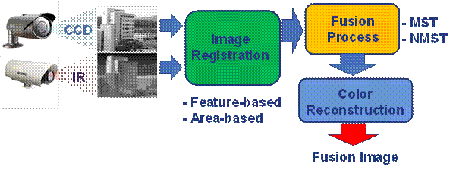

1. **System Requirements**
2. **Software Requirements**

**Language:** MATLAB scripting language

**Operating System:** Windows

**Platform:** MATLAB R2016b

1. **Hardware Requirement**
2. Windows 7 or higher
3. 2GB RAM
4. 6GB HDD
5. **Expected Results**

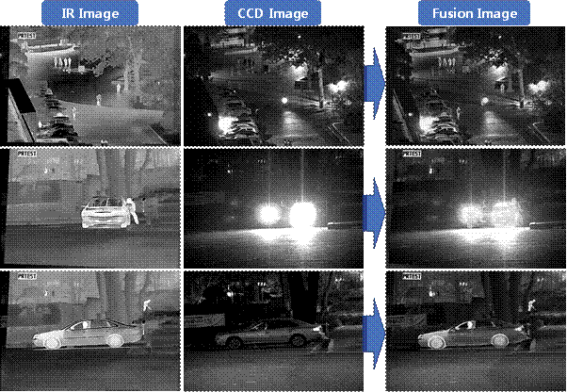

1. **Conclusion and Future Work**

The proposed method estimates the parallax point by appending both input images and IR image is registered. Using a novel method based on techniques like wavelet packet transformation (WPT) model image fusion Is performed considering analysis of input signal at different scale and resolution. In order to perform wavelet packet transformation where Fourier domains are incorporated with high and low band pass filter for estimating mean and maximum fusion values. And also we have done a comparative analysis for ensuring the effectiveness of the proposed system WPT. Our scheme developed to perform SIFT feature extraction as well as estimating parallax point, registration and finally fusion of images.

1. **References**
   * Wei Gan, Xiaohong Wu, Wei Wu, Xiaomin Yang, Chao Ren, Xiaohai He, Kai Liu-"Infrared and visible image fusion with the use of multi-scale edge-preserving decomposition and guided image filter”-ELSEVIER Infrared Physics & Technology, Volume 72,Pages 37–51 September 2015,
   * Qiong Zhang , Xavier Maldague-"An adaptive fusion approach for infrared and visible images based on NSCT and compressed sensing"-ELSEVIER Infrared Physics & Technology, Volume 74,Pages 11–20, January 2016
   * Weiwei Kong , Binghe Wang , Yang Lei-"Technique for infrared and visible image fusion based on non-subsampled shearlet transform and spiking cortical model"-ELSEVIER Infrared Physics & Technology, Volume 71,Pages 87–98, July 2015
   * Chunhui Zhao , Yunting Guo, Yulei Wang-"A fast fusion scheme for infrared and visible light images in NSCT”-ELSEVIER Infrared Physics & Technology, Volume 72, Pages 266–275, September 2015
   * Zhiqiang Zhou, Bo Wang, Sun Li, Mingjie Dong-"Perceptual fusion of infrared and visible images through a hybrid multi-scale decomposition with Gaussian and bilateral filters"-ELSEVIER Information Fusion, Volume 30, Pages 15–26, July 2016,